English Grammar: Irregular Verbs (123)

Base Form | Past Simple | Past Participle  (perfect tenses) | Present Participle  (continuous tenses)
be (am/is/are) | was, were | been | being
bear | bore | born / borne (1) | bearing
beat | beat | beaten | beating
become (2) | became | become | becoming
begin (2) | began | begun | beginning
bend | bent | bent | bending
bet | bet | bet | betting
bind | bound | bound | binding
bite | bit | bitten | biting
bleed | bled | bled | bleeding
blow | blew | blown | blowing
break | broke | broken | breaking
breed | bred | bred | breeding
bring | brought | brought | bringing
build | built | built | building
burn | burned / burnt | burned / burnt | burning
burst | burst | burst | bursting
buy | bought | bought | buying
catch | caught | caught | catching
choose | chose | chosen | choosing
come | came | come | coming
cost | cost | cost | (costing) (3)
cut | cut | cut | cutting
deal | dealt | dealt | dealing
dig | dug | dug | digging
do | did | done | doing
draw | drew | drawn | drawing
dream | dreamed / dreamt | dreamed / dreamt | dreaming
drive | drove | driven | driving
drink | drank | drunk | drinking
eat | ate | eaten | eating
fall | fell | fallen | falling
feed | fed | fed | feeding
feel | felt | felt | feeling
fight | fought | fought | fighting
find | found | found | finding
fit | fit / fitted | fit / fitted | fitting
fly | flew | flown | flying
forbid | Forbade | forbidden | forbidding
forget (2) | forgot | forgot / forgotten | forgetting
forgive (2) | forgave | forgiven | forgiving
freeze | froze | frozen | freezing
get | got | got / gotten | getting
give | gave | given | giving
go | went | gone | going
grow | grew | grown | growing
hang | hung | hung | hanging
have | had | had | (having) (3)
hear | heard | heard | hearing
hide | hid | hidden | hiding
hit | hit | hit | hitting
hold | held | held | holding
hurt | hurt | hurt | hurting
keep | kept | kept | keeping
know | knew | known | (knowing) (3)
lay | laid | laid | laying
lead | led | led | leading
lean | leaned / leant | leaned / leant | leaning
leap | leapt | leapt | leaping
learn | learned / learnt | learned / learnt | learning
leave | left | left | leaving
lend | lent | lent | lending
let | let | let | letting
lie | lay | lain | lying
light | lit | lit | lighting
lose | lost | lost | losing
make | made | made | making
mean | meant | meant | (meaning) (3)
meet | met | met | meeting
pay | paid | paid | paying
put | put | put | putting
quit | quit | quit | quitting
read | read (‘red’) | read (‘red’) | reading
rewind | rewound | rewound | rewinding
ride | rode | ridden | riding
ring | rang | rung | ringing
rise | rose | risen | rising
run | ran | run | running
say | said | said | saying
see | saw | seen | seeing
seek | sought | sought | seeking
sell | sold | sold | selling
send | sent | sent | sending
set | set | set | setting
shake | shook | shaken | shaking
shine | shone | shone | shining
shoot | shot | shot | shooting
show | showed | shown | showing
shrink | shrank | shrunk | shrinking
shut | shut | shut | shutting
sing | sang | sung | singing
sink | sank | sunk | sinking
sit | sat | sat | sitting
sleep | slept | slept | sleeping
speak | spoke | spoken | speaking
spend | spent | spent | spending
spill | spilt | spilt | spilling
split | split | split | splitting
spoil | spoilt | spoilt | spoiling
spread | spread | spread | spreading
spring | sprang | sprung | springing
stand | stood | stood | standing
steal | stole | stolen | stealing
stink | stank | stunk | stinking
strike | struck | struck / stricken | striking
swear | swore | sworn | swearing
sweep | swept | swept | sweeping
swim | swam | swum | swimming
swing | swung | swung | swinging
take | took | taken | taking
teach | taught | taught | teaching
tear | tore | torn | tearing
tell | told | told | telling
think | thought | thought | thinking
throw | threw | thrown | throwing
understand (2) | understood | understood | understanding
wake (up) | woke (up) | woken (up) | waking (up)
wear | wore | worn | wearing
weep | wept | wept | weeping
win | won | won | winning
wind | wound | wound | winding
withdraw (2) | withdrew | withdrawn | withdrawing
write | wrote | written | writing

Observations:

1) The verb “bear” has two meanings:
- “to give birth” (bear/bore/born)
- “to carry” (bear/bore/borne) (see uses in “YouGlish”)

For more details, see:
https://www.merriam-webster.com/words-at-play/borne-vs-born-difference-usage-spelling

Examples of from the series “Outlander”, set in 18th century Scotland:

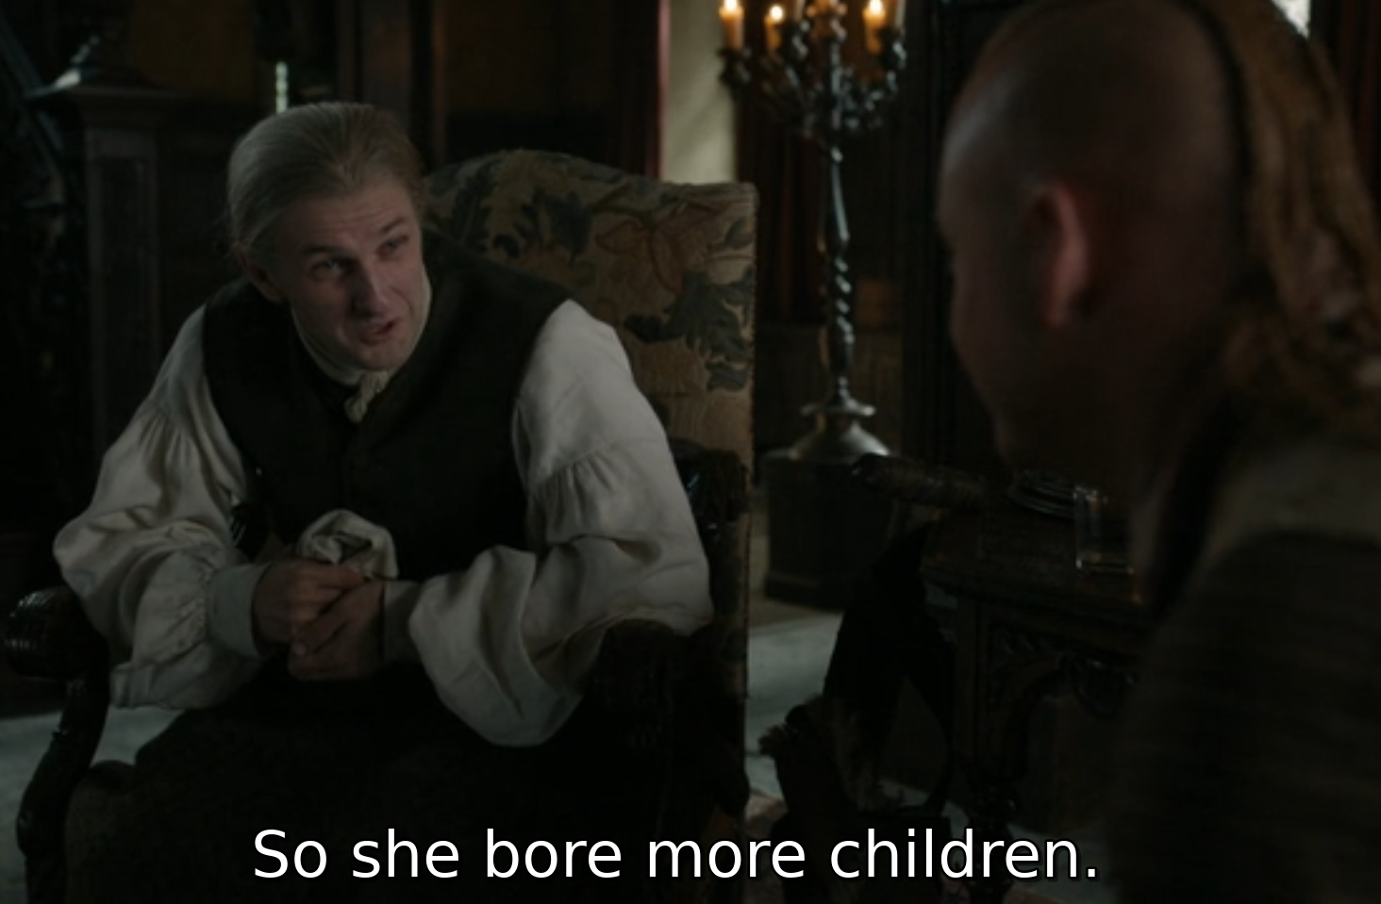

So she had more children.
(most common)

So she gave birth to more children.
(less common)

So she bore more children.
(rare, formal, old-fashioned)

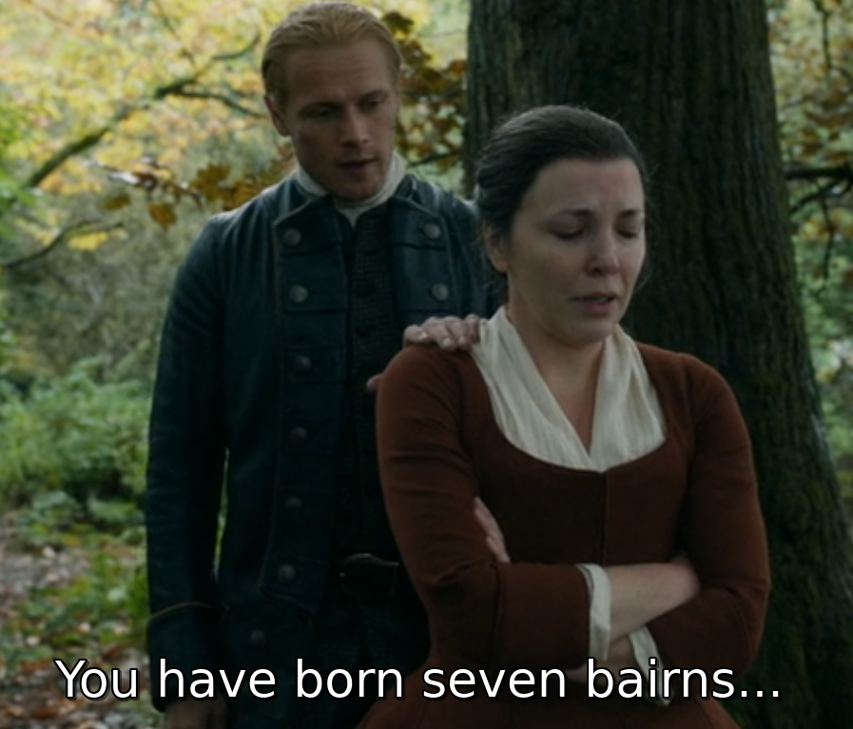

You have had seven children.
(most common)

You have given birth to seven children.
(less common)

You have born seven children.
(rare, formal, old-fashioned)

(“bairn” = “child” in Scottish)

2) “to strike”: https://leangrammar.com/struck-or-stricken-whats-the-past-tense-of-strike/

3) Only 6 of the verbs have more than one syllable, and they are all based on one-syllable verbs:
become, begin, forget, forgive, understand, withdraw

4) The continuous forms of these verbs are rarely used because they are usually state verbs. Continuous verbs are used to describe actions and so are only used for active verbs.

The English language has about 200 irregular verbs. If you included all regional variations and less commonly used verbs, the list would be a little bigger. There are about 60 irregular verbs that are in daily use by about 90% of English speakers (see “Irregular list(common).pdf”).

Irregular verbs song: https://www.youtube.com/watch?v=MA3NFtLc22k (64 verbs in 5 mins)

